There are featurization which are very model specific just like we saw before that if a feature x is power law distributed and we want to apply LR and we know that LR is GNB(Gaussian Naïve Bayes) so we can use log(x).

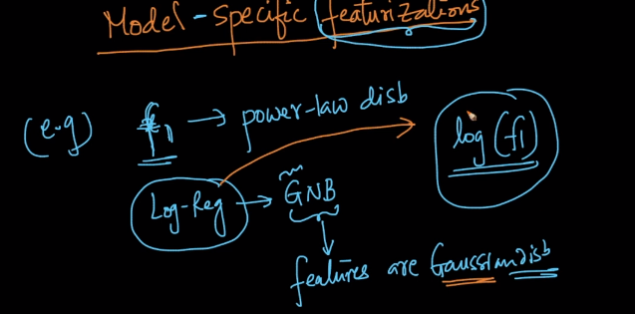

Now take another example, suppose if we know that y can be predicted by combining linear features so we can use that and that can be done with domain knowledge.

In such case our LR will work very well but DT wont work well.

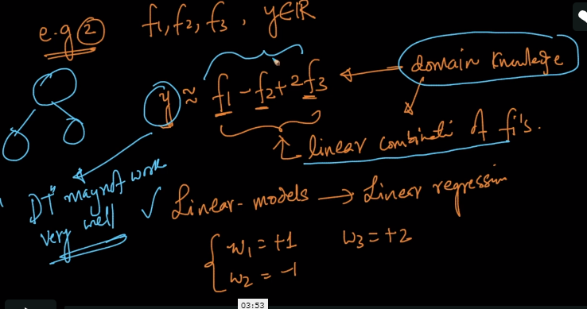

Same can be seen in different cases too like shown below.

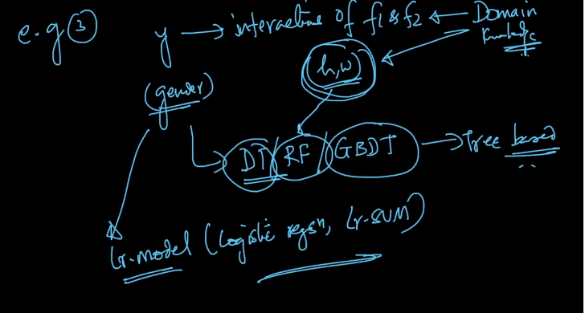

In same it is also dependent on what kind on model you choose. For example if we use large text data and we use BOW which will again increase the count of Feature and so using Lr. SVM, Logistic Regression will work well but in very dimension space sometimes DT may not work well.

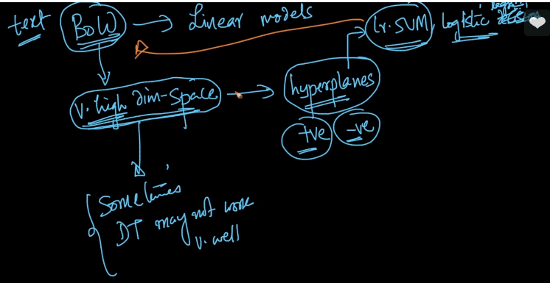

So this means that some model work well for some features and some featurization work well with some model.

So it is all about choosing compitable model and featurization.